CREATE TABLE BANK(BRANCHCODE INT PRIMARY KEY,HEADOFFICE VARCHAR(20),BANKNAME VARCHAR(20),BRANCH VARCHAR(20));
INSERT INTO BANK VALUES (101,'MUMBAI','SBI', 'ERNAKULAM');
INSERT INTO BANK VALUES (102,'MUMBAI','HDFC', 'KOCHI');
INSERT INTO BANK VALUES (103,'MUMBAI','HDFC', 'KOTTAYAM');
INSERT INTO BANK VALUES (104,'MUMBAI','ESAF','PALA');
SELECT * FROM BANK;
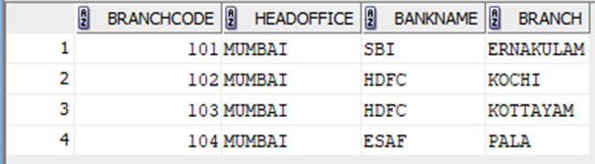

COMMIT
INSERT INTO BANK VALUES (105,'MUMBAI','ESAF','KANJIRAPALLY');
COMMIT ;
SELECT * FROM BANK;
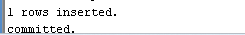
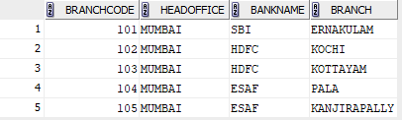
SAVEPOINT
INSERT INTO BANK VALUES (106,'MUMBAI','ICC','MUTHOLY');
SAVEPOINT A;
SELECT * FROM BANK;


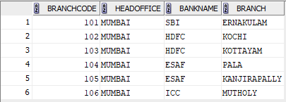
ROLLBACK
ROLLBACK TO B;
SELECT * FROM BANK;
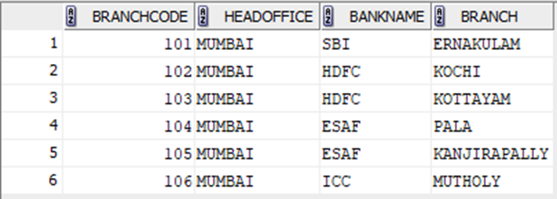
GRANT
GRANT SELECT ON BANK TO c24csa10;
SELECT * FROM c24csa10.BANK;
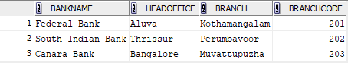
REVOKE
REVOKE SELECT ON BANK FROM c24csa10;

